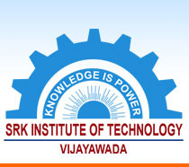 | SRK INSTITUTE OF TECHNOLOGY  Enikepadu, Vijayawada 521108  Approved by AICTE, Affiliated to JNTUK, Kakinada  (ISO 9001:2015 Certified Institution)

7.1.3 Describe the facilities in the Institution for the management of the following types of degradable and
non-degradable waste (within 500 words)

S.No | File Description | Web Link
1 | Solid waste management | www.srkit.in/NAAC/AQAR/Criterion_7/7.1.3/7.1.3(1).pdf
2 | Liquid waste management | www.srkit.in/NAAC/AQAR/Criterion_7/7.1.3/7.1.3(2).pdf
3 | Bio Medical waste management | www.srkit.in/NAAC/AQAR/Criterion_7/7.1.3/7.1.3(3).pdf
4 | E-waste management | www.srkit.in/NAAC/AQAR/Criterion_7/7.1.3/7.1.3(4).pdf
5 | Chemical waste management | www.srkit.in/NAAC/AQAR/Criterion_7/7.1.3/7.1.3(5).pdf

