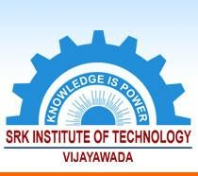

**5.4.1 *There is a registered Alumni Association that contributes significantly to the development of the institution through financial and/or other support services***

**SRK INSTITUTE OF TECHNOLOGY**

**Enikepadu, Vijayawada 521108**

**Approved by AICTE, Affiliated to JNTUK, Kakinada (ISO 9001:2015 Certified Institution)**

|  |  |
| --- | --- |
| **Web Link** | [www.srkit.in/NAAC/AQAR/Criterion_5/5.4.1/5.4.1.pdf](http://www.srkit.in/NAAC/AQAR/Criterion_5/5.4.1/5.4.1.pdf) |