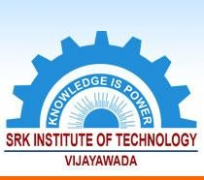

**2.2.1. *The institution assesses the learning levels of the students and organises special Programmes for***

**SRK INSTITUTE OF TECHNOLOGY**

**Enikepadu, Vijayawada 521108**

**Approved by AICTE, Affiliated to JNTUK, Kakinada (ISO 9001:2015 Certified Institution)**

***advanced learners and slow learners***

|  |  |
| --- | --- |
| **Web Link** | [www.srkit.in/NAAC/AQAR/Criterion_2/2.2.1/2.2.1.pdf](http://www.srkit.in/NAAC/AQAR/Criterion_2/2.2.1/2.2.1.pdf) |