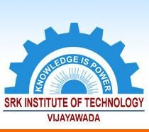

**1.3.1. *Institution integrates crosscutting issues relevant to Professional Ethics, Gender, Human Values,***

**SRK INSTITUTE OF TECHNOLOGY**

**Enikepadu, Vijayawada 521108**

**Approved by AICTE, Affiliated to JNTUK, Kakinada (ISO 9001:2015 Certified Institution)**

***Environment and Sustainability into the Curriculum***

|  |  |
| --- | --- |
| **Web Link** | [www.srkit.in/NAAC/AQAR/Criterion_1/1.3.1/1.3.1.pdf](http://www.srkit.in/NAAC/AQAR/Criterion_1/1.3.1/1.3.1.pdf) |