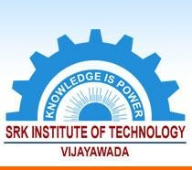

* + 1. ***The Institution ensures effective curriculum delivery through a well planned***

**SRK INSTITUTE OF TECHNOLOGY**

**Enikepadu, Vijayawada 521108**

**Approved by AICTE, Affiliated to JNTUK, Kakinada (ISO 9001:2015 Certified Institution)**

***and documented process***

|  |  |
| --- | --- |
| **Web Link** | [www.srkit.in/NAAC/AQAR/Criterion_1/1.1.1.pdf](http://www.srkit.in/NAAC/AQAR/Criterion_1/1.1.1.pdf) |